Lab Book – Optical Cavity

Bryden Fogelman - 36294130

James Wasteneys – 34140137

**MON MAR 12, 2018**

**Task List**

As usual, we are going to spend the first lab playing around with the equipment.

* Alignment – There was a step by step video for aligning provided on Canvas, we will be following this to align the cavity.
* Mirror reflectivity – We need to determine the reflection and transmission coefficients of the mirrors inside the cavity. We will use the power meter to measure the incident, reflected and transmitted power.

**Alignment / Optical Cavity Setup**

Following the video provided on Canvas, we aligned the laser in the following way:

* Remove the first mirror (M1) in the cavity and try and first to align the first two turning mirrors
  + This is done by moving the second mirror (M2) of the cavity along the rail
  + First move M2 far along the rail and adjust the far turning mirror
  + Move M2 closer to the second turning mirror and make fine adjustments with the second turning mirror
  + Move M2 farther back and repeat the tuning process above until convergence
* Place the lens in between the two turning mirrors at an approximate distance of 50cm from M1
  + Make the height is properly aligned for this lens, so we had to repeat a similar process as before
* Next place in M1 and make sure that the reflected light from M1 lays over top of the incident light (look at the first turning mirror)
* Finally align M2 so that the reflected light of M2 overlaps with the transmitted light from M1

**Mirror Reflectivity**

Procedure:

* First using the aligned system we calculated the incident power after the second turning mirror
* Next we calculated the Transmitted coefficient for M1 and M2 by placing the power meter behind the mirror
  + Note, we made sure to rotate M1 around 180 degrees since we are trying to characterize what is inside the cavity
* We then had to un-align the system to record the reflectivity coefficient for M1 and M2

Results:

The following Matlab code contains the data measured using the power meter and calculations of uncertainty for R, T for both mirrors.

%% Mirror Reflectivity

%Incident Power $= 6.63 \pm .015 $mW (Note: loss due to alignment mirror,

%so did after mirror)

P_I = 6.63e-3; %W

% M1 Transmitted Power = 82.5 \pm 1.5 \mu W

% P_M1_trans = 82.5e-6; %W

% % M1 Relected Power = 5.93 \pm .05 $mW

% P_M1_ref = 5.93e-3; %W

% ^above measurements use wrong side of mirror (not shiny side)

% ------------ %

% FIRST MIRROR %

% ------------ %

% M1 Transmitted Power = 77 \pm 1 \mu W

P_M1_trans = 77.5e-6; %W

% M1 Relected Power = 6.43 \pm .05 $mW

P_M1_ref = 6.43e-3; %W

% Reflection coefficient

R_M1 = P_M1_ref/P_I

delta_R_M1 = (0.05e-3 / P_M1_ref + 0.015e-3 / P_I) * R_M1

% Transmission Coefficient

T_M1 = P_M1_trans/P_I

delta_T_M1 = (1e-6 / P_M1_trans + 0.015e-3 / P_I) * T_M1

%Should add to 1

T_M1 + R_M1

% ------------- %

% SECOND MIRROR %

% ------------- %

% M2 Transmitted Power = 124 \pm 1 \mu W

P_M2_trans = 124e-6; %W

% M2 Reflected Power = 6.35 \pm .01 mW

P_M2_ref = 6.35e-3; %W

% Reflection coefficient

R_M2 = P_M2_ref/P_I

delta_R_M2 = (0.01e-3 / P_M2_ref + 0.015e-3 / P_I) * R_M2

% Transmission Coefficient

T_M2 = P_M2_trans/P_I

delta_T_M1 = (1e-6 / P_M2_trans + 0.015e-3 / P_I) * T_M2

% Should add to 1

T_M2 + R_M2

|  |  |  |
| --- | --- | --- |
|  | Mirror 1 | Mirror 2 |
| R | $$0.97±0.01$$ | $$0.958±0.004$$ |
| T | $$0.0117±0.0002$$ | $$0.0187±0.0002$$ |
| R + T | $$0.98±0.01$$ | $$0.977±0.004$$ |

Questions:

Q: Do your reflectivity and transmission coefficients add to 1? Should they?

Our values do not add to one. This occurs because the mirrors are not ideal and there is some loss due to absorption. The coefficients are also angle dependent so this may also account for some loss. Overall, our values are pretty close to 1 which should be good enough for this lab.

Q: Calculate the Finesse that you expect the cavity to have.

A quick calculation gives us the following value

$$F=\frac{π{\left(R_{1}R_{2}\right)}^{0.25} }{\left(1-\sqrt{R_{1}R_{2}}\right)}=85.64$$

Q: Given this finesse, for a cavity with length L=15 cm, what do you expect the cavity linewidth and free spectral range to be? Express your answer in MHz and nm. Which do you think is a better unit of measure in this context?

The expected FSR is given below

$$FSR=\frac{c}{2d}=\frac{3*{10}^{8} m/s}{2*\frac{15}{100}m}=1*{10}^{9} Hz=1000 MHz$$

$$Δf_{FWHM}=\frac{FSR}{F}=\frac{1000 MHz}{85.64}=11.67 MHz$$

The cavity line width is as follows

$$Δτ=\frac{1}{2π}Δf_{FWHM}^{-1}=13.63 nm$$

For the FSR, a better unit of measure should be gigahertz.

Q: What would happen to the cavity characteristics if the low reflectivity sides of the mirror faced each other?

The FSR would remain unchanged but the finesse value would decrease. Since the finesse decreases, the FWHM would increase and as a result the cavity line width would decrease. The intensity of the beam within the cavity would also decrease.

**MON MAR 19, 2018**

**Task List**

At the start of the lab we quickly verified the alignment of the laser

* Perform a knife edge measurement and calculate the beam width
  + Calculate the incident power
  + Find the location where the power is at 10% and 90% of the incident
* Piezo Calibration
  + Apply a triangular wave the piezo and

**Beam Radius**

Procedure:

* Measure the incident beam power using the power meter
* Place the knife edge in the place of M1
  + Place the power meter behind M1
* Start with the beam fully passing through the knife edge and slowly adjust the position of M1 using the motor
  + Measure the position when the power reaches 90% and 10% of the incident beam

Questions/Results:

Q: Sketch the beam shape and phase fronts of the cavity mode. Where is the focus of the beam?



*Sketch of Beam shape and wavefronts*

The focus of the beam occurs at M1 due to the conical shape of M2 (wherever the wavefronts are parallel).

Q: At what location should the beam come to a focus in order to best mode match into the cavity?

The beam should come into focus at the location of M1.

Q: Measure the minimum beam width at the focus with the knife edge.

First, we used the 40cm lens in this calculation as it was the best available lens. We know the power of the incident beam is $P_{I}=6.63±0.02 mW$. Using the power meter, we calculated the power at 90% and 10% and the position where it occurred.

|  |  |
| --- | --- |
| **Power** | **Position** |
| $$P_{90}=5.96±0.03 mW$$ | $$x_{10}= 11.256±0.001 mm$$ |
| $$P_{10}=0.66±0.1 mW$$ | $$x_{90}= 10.981±0.001 mm$$ |

With the two positions calculated above we can calculate the beam radius.

$$w=0.7803\left(x_{10}-x_{90}\right)=0.214±0.001 mm$$

Q: What beam waist should you have in order to best mode match into the cavity?

The beam waist that we should have can be calculate from the Rayleigh’s length:

$$W_{0}=\sqrt{\frac{λz_{0}}{π}}$$

The textbook (Saleh and Teich) gives the Rayleigh length for two symmetric mirrors:



Since M1 is actually planar, we take the limit as R1 goes to infinity (using L’Hopital’s rule):

$$z_{0}^{2}=-d(R_{2}+d)$$

Setting R2 = 30cm, d = 15cm and the wavelength of the laser is 632.8 nm we get the following beam width. Note, we use d=15cm because this is in the middle range of where our cavity will be operated at.

$$W_{0}=\sqrt{\frac{λ{\left(d\left(R_{2}+d\right)\right)}^{0.5}}{π}}=0.2288mm$$

We can see that our beam widths almost agree within an uncertainty and at least agree with the first digit. There is a discrepancy here because this beam width is calculated with the focal length of the lens is optimal

Q: Given your answer for the ideal beam waist, what would be the ideal focal length lens to use? How far from the M1 should it be placed?

From Steck, the following equation characterizes the width of the beam at M1:



$$w_{02}≅\frac{λf}{πw_{01}}$$

*Figure illustrating the setup of this cavity, with the beam waist labelled.*

Let’s assume $w_{01}=0.4mm$ (this value was provided from a previous lab book).

$$f=\frac{πw_{02}w_{01}}{λ}=\frac{π* 0.2288 mm* 0.4 mm}{632.8 nm}= 45 cm$$

The closest lens we have in the lab to the focal length found above is 50cm or 40cm. Since the 50cm lens had large finger prints, we decided to use the 40cm lens. The lens should be placed at least 40cm from M1 (d is approximately equal to the focal length of the lens).

**Piezo Calibration**

Procedure:

Below outlines the method we used to retrieve the calibration data:

* We applied a triangular wave using the function generator
  + This was applied to the piezo as this would give a linear increasing and decreasing voltage
  + This also means that the position of the piezo would increase and decrease linearly
* Next, we attempted to have three peaks appear per half a wavelength (have a periodic pattern repeat)

Questions/Results:

Below shows some plots that appeared on the oscilloscope.

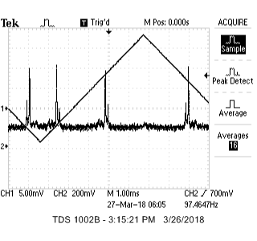 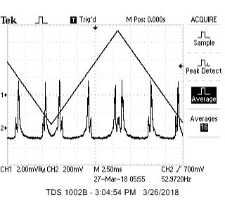

*Examples of output from the oscilloscope*

Q: What is the specification for the ThorLabs piezo you are using?

The specification given on the datasheet is $11.6±2.0 μm/V$

Q: Find experimentally the calibration of the piezo. Does it agree with the specification?

Using the dataset that gave use the most peaks, we calculated the calibration constant to be .

As we can see, the experimentally determined calibration constant does not agree

We determined that the best method for calibration would be to recalculate the calibration constant for each dataset.

**Cavity Observations**

Throughout this lab we struggled with fringes that were appearing on our camera, there was some issue with the experimental setup. Even with the cavity aligned, we struggled to find good images of the modes. We worked with the TAs and weren’t able to come up with a solution so we decided to move to a different experiment for the last lab.

**MON MAR 26, 2018**

**Task List**

This lab we need to record data to calculate the finesse of the optical cavity as we think this is the most important part of the lab.

* Retrieve data for the FWHM of three different cavity lengths
  + At small distances (1 cm)
  + Medium distances (10-15cm)
  + Large distances (close to edge of stability)
* Attempt to observe as many modes as we can within the cavity
  + In the last lab we were unable to see any modes due to issues with the setup that could not be resolved with the help of the TAs

**Cavity Observations**

Procedure

* To record the images of the modes we directed the beam from the cavity in the camera and took multiple photos to try and capture and image
  + We did this over multiple different lengths
* To record data for the transmission pattern, we again applied a triangular wave to the piezo using the function generator
  + First we followed the triggering tutorial provided in the lab manual
  + We adjusted the frequency and voltage on the function generator so that enough we could display multiple peaks
  + We would cycle through different transmission patterns using stop/run on the oscilloscope until we found an optimal transmission signal (corresponding to mode TEM00)
  + Using the average function on the oscilloscope, we cleaned up the signal

Observations of Modes

Using the CCD camera we found and recognized the following modes:

|  |  |  |
| --- | --- | --- |
| TEM00 | TEM11 (Laguerre-Gaussian) | TEM30 (Hermite-Gaussian) |
| TEM 02 (Laguerre-Gaussian) | TEM 02 (Laguerre-Gaussian) | TEM30 (Hermite-Gaussian) |

The following images appear to be higher order modes but we are unsure which l,m values they correspond too as the quality of the image was poor.

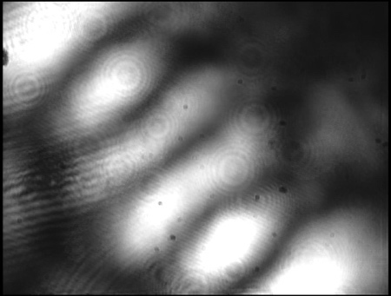 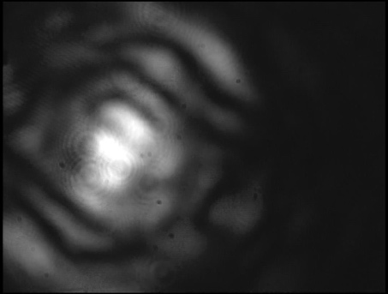 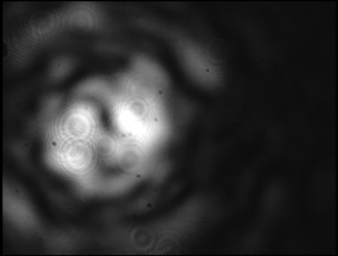

Transmission Signals and Data

First we looked at retrieving data for multiple peaks. Using the software provided on the computer we saved images and waveforms of the data.



*Transmission signal with multiple peaks at L = 1.5 cm*

*Data: scope_multiple_L1_5cm_mar26_308.csv*

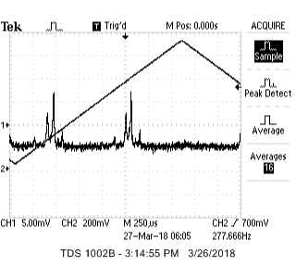

*Transmission signal with multiple peaks at L = 28cm*

*Data: multiple_L28cm_mar26_448.csv*

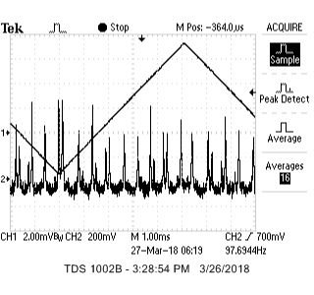

*Transmission signal with multiple peaks at L = 13 cm*

*Data:* *scope_multiple_L13cm_mar26_329.csv*

We then went back and recorded zoomed in transmission peaks to see if there was a difference in values. Note, using the multiple peaks can provide us with an uncertainty but the zoomed in peaks have a higher resolution.

|  |  |
| --- | --- |
| *FWHM at L = 1cm*  *Data: fwhm_data_L1cm_mar26_332.csv* | FWHM at L = 3cm  Data: fwhm_L3cm_mar26_436.csv |
| *FWHM at L = 13cm*  *Data: fwhm_L13cm_mar26_328.csv* | FWHM at L = 23cm  Data: *fwhm_L23cm_mar26_426.csv* |

This data was then used to determine the finesse and cavity line width in the Resonator Finesse section.

Questions

Q: Does the long or short cavity have more visible transverse modes? Why?

Longer cavities tend to show more modes because higher order modes can be excited, recall $q=\frac{2d}{λ}$.

Q: Why do you see multiple peaks that repeat periodically, rather than just one? Which cavity mode likely corresponds to the largest transmission peak?

Multiple peaks appear periodically because the piezo itself is vibrating. The piezo moves at very small distances and is sensitive to small movements. The mode TEM00 corresponds to the largest transmission peak.

Q: Why do different transverse modes occur at different cavity lengths?

The resonance condition is dependent on the geometry of the cavity, which changes as we increase the length. The formula below shows this dependence on the resonance condition (both g1 and g2 are dependent on the cavity length).



**Resonator Finesse**

Procedure

Verify this is right Jimmy

* Using the data we obtained from the oscilloscope in the cavity observations section we computer the Finesse and Cavity Line width
* We found that it was easier to analyze the data with multiple peaks because it was easier to calibrate
  + We know that the distance between peaks is $\frac{λ}{2}$, we used this to convert to a position scale
  + We then used a built in MATLAB function to compute the FWHM called *findpeaks*
  + To determine the uncertainty, we took the deviation between the FWHM from different peaks
  + Using the cavity length we then calculated the FSR and then the Finesse

Questions/Results

RESULTS HERE

Q: Measure the free spectral range, linewidth and finesse of your cavity as a function of cavity length. Be very clear about the units of your measurements. Hint: The free spectral range and linewidth of the cavity should be on the order of 10 to 100s of MHz.

Q: Plot the cavity finesse and cavity linewidth as a function of cavity length. On the same figure, plot the expected cavity finesse (you found this earlier) and the expected cavity linewidth (given the expected finesse). Do your results agree or disagree with what you expect?

Q: From these results, what can you say about the spectral linewidth of the HeNe laser?

Q: What is the Q -factor of your cavity?

Q: Consider a tuning fork oscillating at 440 Hz (this is what musicians often use to tune their instruments). How long would the tuning fork ring given it had the same Q -factor as your optical cavity? Is this reasonable?